Separated Collinear Segments

Definition
# Source: AI Source: Provided by: [Data Path: Persons Table -> ID Column: 1, Name_En Column: Motasem Essam] -> From: [ChatGPT] on [7/25/2026]
Separated Collinear Segments are two or more line segments that:
- lie on the same supporting straight line, and
- have a positive gap between them.
For two segments $\overset{‾}{AB}$and $\overset{‾}{CD}$:
$$\overset{‾}{AB}⊆l \\ \overset{‾}{CD}⊆l$$
and the segments have no common point:
$$\overset{‾}{AB}∩\overset{‾}{CD}=∅$$
Therefore, their separation distance is positive:
$$\boxed{g>0}$$
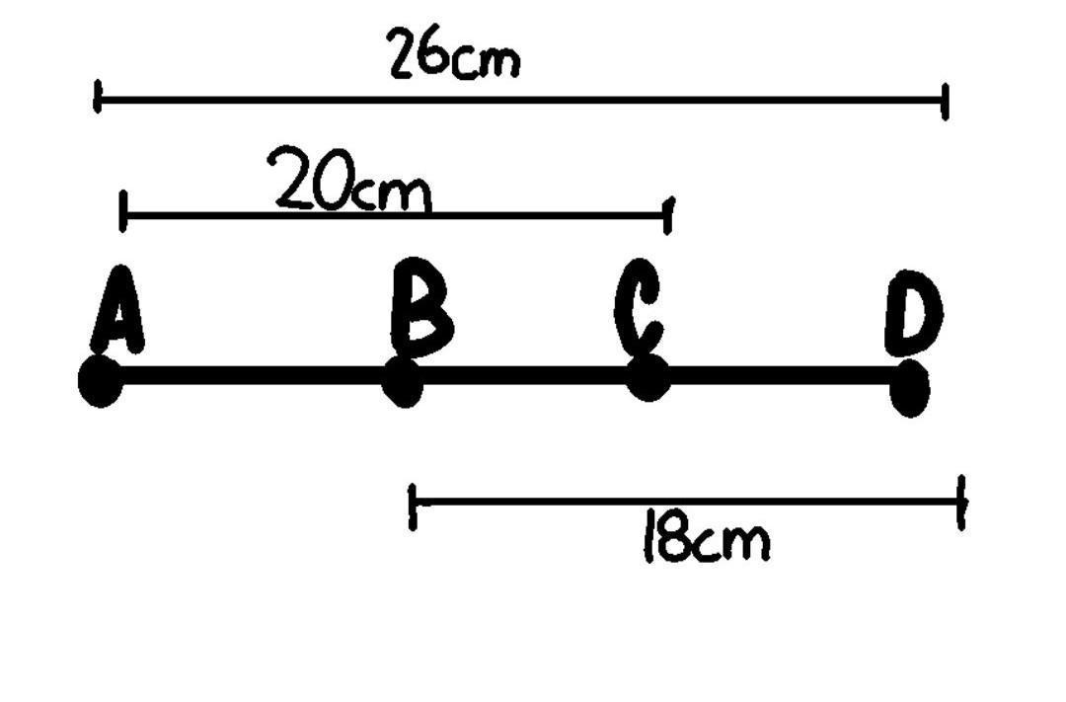
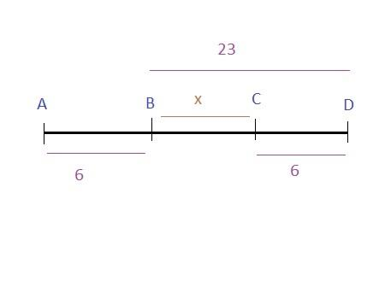
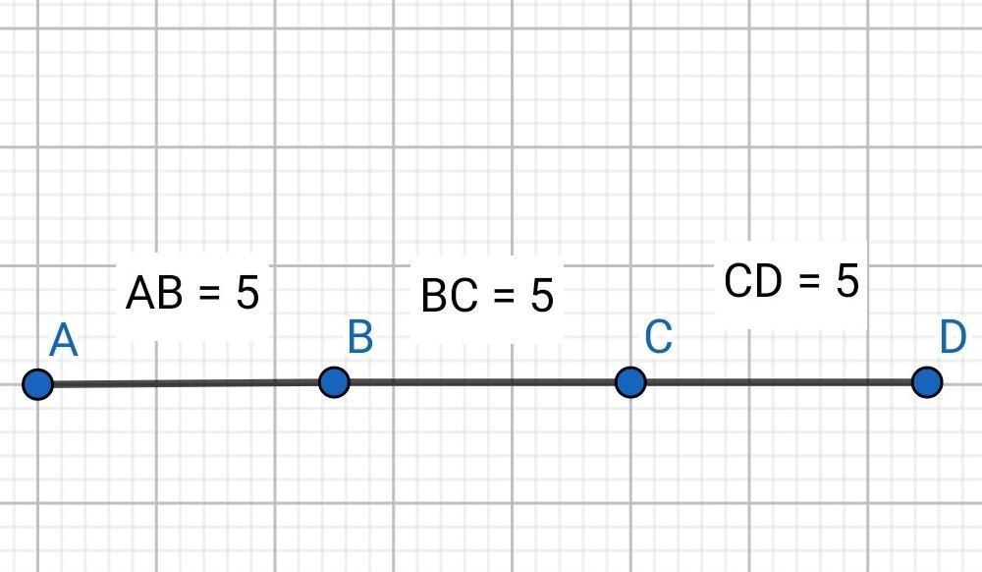

Purpose
# Source: AI Source: Provided by: [Data Path: Persons Table -> ID Column: 1, Name_En Column: Motasem Essam] -> From: [ChatGPT] on [7/25/2026]
Separated collinear segments are used to describe situations where line segments:
- share the same straight-line direction and supporting line;
- do not touch each other;
- do not overlap;
- have a measurable gap between them;
- can be analyzed using one-dimensional distances.

Fundamental Concept
# Source: AI Source: Provided by: [Data Path: Persons Table -> ID Column: 1, Name_En Column: Motasem Essam] -> From: [ChatGPT] on [7/25/2026]
The essential relationship is:
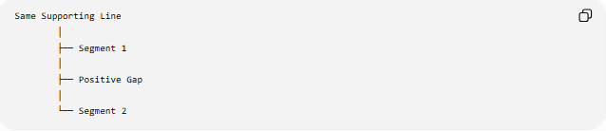
Same Supporting Line
│
├── Segment 1
│
├── Positive Gap
│
└── Segment 2
Geometrically:
A ●────────● B C ●────────● D
<── g ──>
The segments are collinear because they lie on the same line, but separated because they have no common points.

Mathematical Conditions
# Source: AI Source: Provided by: [Data Path: Persons Table -> ID Column: 1, Name_En Column: Motasem Essam] -> From: [ChatGPT] on [7/25/2026]
For two segments $\overset{‾}{AB}$and $\overset{‾}{CD}$, separated collinearity requires:
1. Common supporting line
$$A,B,C,D∈l$$
2. No common points
$$\overset{‾}{AB}∩\overset{‾}{CD}=∅$$
3. Positive gap
$$\boxed{g>0}$$
Together:
$$\boxed{\overset{‾}{AB},\overset{‾}{CD}⊆l \text{and} \overset{‾}{AB}∩\overset{‾}{CD}=∅}$$

Interval Representation
# Source: AI Source: Provided by: [Data Path: Persons Table -> ID Column: 1, Name_En Column: Motasem Essam] -> From: [ChatGPT] on [7/25/2026]
When both segments lie on the same coordinate axis, represent them as intervals:
$$S_{1}=\left[a , b\right] \\ S_{2}=\left[c , d\right]$$
Assume:
$$a<b<c<d$$
Then:
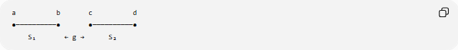
a b c d
●──────────● ●──────────●
S₁ ← g → S₂
The gap is:
$$\boxed{g=c-b}$$
If the second segment is located before the first:
$$c<d<a<b$$
then:
$$\boxed{g=a-d}$$
In general:
$$\boxed{g=\left\{\begin{matrix}c-b, & b<c \\ a-d, & d<a\end{matrix}\right.}$$

Example 1 — Horizontal Segments
# Source: AI Source: Provided by: [Data Path: Persons Table -> ID Column: 1, Name_En Column: Motasem Essam] -> From: [ChatGPT] on [7/25/2026]
Consider:
$$A\left(1 , 4\right), B\left(5 , 4\right)$$
and:
$$C\left(9 , 4\right), D\left(13 , 4\right)$$
All four points lie on:
$$y=4$$
Therefore, the segments are collinear.
Their nearest endpoints are $B\left(5 , 4\right)$and $C\left(9 , 4\right)$.
The gap is:
$$g=9-5 \\ \boxed{g=4}$$
Thus:
$$\boxed{\overset{‾}{AB}\text{ and }\overset{‾}{CD}\text{ are separated collinear segments}}$$

Example 2 — Vertical Segments
# Source: AI Source: Provided by: [Data Path: Persons Table -> ID Column: 1, Name_En Column: Motasem Essam] -> From: [ChatGPT] on [7/25/2026]
Consider:
$$A\left(3 , 1\right), B\left(3 , 4\right)$$
and:
$$C\left(3 , 8\right), D\left(3 , 11\right)$$
All points lie on:
$$x=3$$
The nearest endpoints are:
$$B\left(3 , 4\right), C\left(3 , 8\right)$$
Therefore:
$$g=8-4=4$$
So:
$$\boxed{g=4}$$

Example 3 — Oblique Segments
# Source: AI Source: Provided by: [Data Path: Persons Table -> ID Column: 1, Name_En Column: Motasem Essam] -> From: [ChatGPT] on [7/25/2026]
Consider two segments lying on the line:
$$y=2x+1$$
Suppose the nearest endpoints are:
$$B\left(2 , 5\right)$$
and:
$$C\left(5 , 11\right)$$
The coordinate difference is:
$$Δx=5-2=3 \\ Δy=11-5=6$$
Therefore, the Euclidean gap is:
$$g=\sqrt{3^{2}+6^{2}} \\ g=\sqrt{45} \\ \boxed{g=3\sqrt{5}}$$
The segments remain collinear because their endpoints lie on the same supporting line.

Nearest-Endpoint Principle
# Source: AI Source: Provided by: [Data Path: Persons Table -> ID Column: 1, Name_En Column: Motasem Essam] -> From: [ChatGPT] on [7/25/2026]
For separated collinear segments, the gap is measured between the closest endpoints.
For:
A ●────────● B C ●────────● D
the relevant endpoints are:
$$B \text{and} C$$
Therefore:
$$\boxed{g=BC}$$
when $B$and $C$are the nearest endpoints.

Properties
# Source: AI Source: Provided by: [Data Path: Persons Table -> ID Column: 1, Name_En Column: Motasem Essam] -> From: [ChatGPT] on [7/25/2026]
1. Same supporting line
Both segments must lie on one common line:
$$\overset{‾}{AB},\overset{‾}{CD}⊆l$$
2. No intersection
$$\overset{‾}{AB}∩\overset{‾}{CD}=∅$$
3. Positive gap
$$g>0$$
4. No overlap
They share no portion of their lengths.
5. No contact
They do not share an endpoint.
6. One-dimensional analysis
Once a common supporting line is established, their positional relationship can be analyzed as intervals on a single dimension.

Separated vs. Touching Collinear Segments
# Source: AI Source: Provided by: [Data Path: Persons Table -> ID Column: 1, Name_En Column: Motasem Essam] -> From: [ChatGPT] on [7/25/2026]
The difference is the gap.
Separated
A ●──────● B C ●──────● D
g>0
$$g>0$$
Touching
A ●──────● B=C──────● D
$$g=0$$
Therefore:
$$\boxed{g>0⇒\text{separated}} \\ \boxed{g=0\text{ with a shared endpoint}⇒\text{touching}}$$

Separated vs. Overlapping Collinear Segments
# Source: AI Source: Provided by: [Data Path: Persons Table -> ID Column: 1, Name_En Column: Motasem Essam] -> From: [ChatGPT] on [7/25/2026]
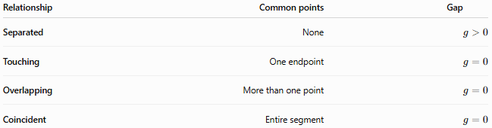
Relationship | Common points | Gap
Separated | None | $$g>0$$
Touching | One endpoint | $$g=0$$
Overlapping | More than one point | $$g=0$$
Coincident | Entire segment | $$g=0$$
Thus, a positive gap uniquely identifies separated segments among these four relationships.

Coordinate Classification
# Source: AI Source: Provided by: [Data Path: Persons Table -> ID Column: 1, Name_En Column: Motasem Essam] -> From: [ChatGPT] on [7/25/2026]
For intervals:
$$S_{1}=\left[a , b\right]$$
and:
$$S_{2}=\left[c , d\right]$$
with $a≤b$and $c≤d$:
Separated
$$\boxed{b<c \text{or} d<a}$$
Touching
$$b=c$$
or:
$$d=a$$
Overlapping
$$max⁡\left(a , c\right)<min⁡\left(b , d\right)$$
Coincident
$$a=c, b=d$$

Relationship to Gaps
# Source: AI Source: Provided by: [Data Path: Persons Table -> ID Column: 1, Name_En Column: Motasem Essam] -> From: [ChatGPT] on [7/25/2026]
Separated Collinear Segments are directly related to the previously defined Linear Gap.
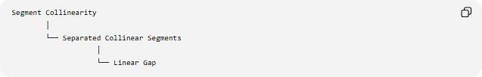
Segment Collinearity
│
└── Separated Collinear Segments
│
└── Linear Gap
For separated segments:
$$\boxed{g>0}$$
The gap itself is the empty interval between the nearest endpoints.

Relationship to Contact
# Source: AI Source: Provided by: [Data Path: Persons Table -> ID Column: 1, Name_En Column: Motasem Essam] -> From: [ChatGPT] on [7/25/2026]
Separated collinear segments have:
$$\overset{‾}{AB}∩\overset{‾}{CD}=∅$$
Therefore, they have no contact.
If the gap decreases to zero and the nearest endpoints become identical, the relationship changes from:
$$\text{Separation}$$
to:
$$\text{Contact / Touching}$$
Conceptually:
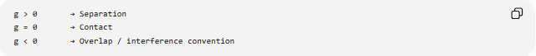
g > 0 → Separation
g = 0 → Contact
g < 0 → Overlap / interference convention
For ordinary geometric segments, the $g<0$convention is better interpreted through interval overlap rather than as a literal geometric "negative gap."

Key Points
# Source: AI Source: Provided by: [Data Path: Persons Table -> ID Column: 1, Name_En Column: Motasem Essam] -> From: [ChatGPT] on [7/25/2026]
- Separated collinear segments lie on the same supporting line.
- They have no common points.
- There is a positive gap between them.
- The gap is measured between their nearest endpoints.
- For intervals $\left[a , b\right]$and $\left[c , d\right]$, separation occurs when $b<c$or $d<a$.
- They differ from touching segments because touching segments have $g=0$.
- They differ from overlapping segments because overlapping segments share a portion of their lengths.
- They differ from coincident segments because coincident segments occupy exactly the same points.

Conclusion
# Source: AI Source: Provided by: [Data Path: Persons Table -> ID Column: 1, Name_En Column: Motasem Essam] -> From: [ChatGPT] on [7/25/2026]
Separated Collinear Segments are line segments that share one supporting straight line while remaining completely disjoint and separated by a positive distance. They represent the separation case of segment collinearity, with the defining condition:
$$\boxed{\overset{‾}{AB}∩\overset{‾}{CD}=∅, g>0}$$

